Heading
- The AI-Powered Growth Partner Behind Modern Brands
- AI-Driven Growth. Full-Service Digital Marketing & IT.

SUBHEAD
We're a full-service digital marketing and IT partner — SEO, paid media, web & app development, branding and creative, powered by AI-driven insight. Brands we work with don't just show up. They get found.
STATS ROW
- 80+ — Brands launched
- 3.4× — Avg. traffic lift
- 9 yr — Building
CTAS
Start your project · See our work

Intro / Positioning
LINE
We don't chase trends. We build digital momentum.
BODY
Strategy, growth, technology, and creative — all under one roof, moving in the same direction. No juggling vendors, no mixed signals. One team, measurable results.

Services
EYEBROW
What we do
HEADLINE
Digital Marketing services at Diversify Digital
INTRO
Every service we offer plays a role in one connected growth system. Nothing works in isolation — each stage builds on the last.

SEO (Attention)
Get found where it matters
Rank for what buyers actually search — technical foundations, content and authority that move you up and keep you there.
- Technical SEO — Site speed, crawlability, indexing and structured data that give search engines no reason to skip you
- Content Strategy — Topic clusters, keyword mapping and editorial calendars built around real buyer intent
- Link Building — Authority and trust signals from real sources, not spammy shortcuts that put your rankings at risk
- Local SEO — Google Business optimization, citations and map pack visibility for brands that live and win locally
CTA: Discuss SEO

Google & Meta Ads (Discovery)
Ads built for intent — not just reach.
Paid campaigns built on intent, not guesswork. Every dollar tracked back to real pipeline — not vanity clicks.
- Search & Shopping Ads — Capture demand at the exact moment someone's ready to buy
- Meta Campaigns — Reach, retarget, and convert across Facebook & Instagram
- Conversion Tracking — Full-funnel attribution, no black boxes, no guesswork
- Creative Testing — Continuous iteration on the ads, copy, and creative that actually convert
CTA: Discuss ads

Web & App Development (Experience)
Build the thing people land on
Fast, considered, conversion-ready builds — from marketing sites to full digital products — so every visitor you earn actually sticks around.
- Web Development — Marketing sites, e-commerce stores, custom builds engineered for speed and conversion
- App Development — Native and cross-platform apps built for real users, not just app-store screenshots
- Performance Engineering — Page speed, accessibility, and Core Web Vitals tuned so nothing slows growth down
- Ongoing Maintenance — We don't disappear at launch. Updates, monitoring, and support keep things running long after go-live
CTA: Discuss development

Branding & Creative (Identity)
Don't just look good. Be memorable.
A brand isn't a logo file — it's every impression people form of you. We build identities that hold their shape across every screen, page, and platform.
- Brand Identity — Logo, design system, brand guidelines
- Graphic Design — Campaign creative, social assets, print collateral
- Messaging & Voice — What you say, how you say it, and why it sticks
- Video & Photography — Real, in-house production — no stock footage
- CTA: Discuss branding

Social Media (Engagement)
Social that actually works.
Followers are easy. A real audience isn't. We build consistent social presence, on-brand, and built to convert — not just rack up likes.
- Content Calendars — Planned, not improvised
- Community Management — Actual conversations, not silence
- Platform Strategy — Focused effort where your audience actually is
- Performance Reporting — Data that tells you what to do next
CTA: Discuss social

Growth Strategy (Growth)
One roadmap. No guesswork.
Disconnected tactics don't compound. A plan does. We build the roadmap that ties every channel to one goal — and we run it.
- Growth Audits — Where you're leaking opportunity
- Road mapping — Quarter-by-quarter priorities, sequenced by impact
- Cross-Channel Strategy SEO, paid, brand, and product, working toward the same numbers
- Reporting & Iteration — Real numbers, reviewed on a real cadence, with changes made when the data calls for it
CTA: Discuss strategy

Why Choose Diversify Digital for Digital Marketing Services?
- Strategy before tactics — Every channel ties back to a real roadmap, not a checklist
- Built for the AI-era search — Optimized for both traditional rankings and AI-driven discovery
- Technical foundation that supports growth — Speed, structure, and clean code, done right
- Conversion is part of the plan — Built to turn visitors into leads, not just clicks
- Measurement that connects to revenue — Tracked against pipeline and revenue, not vanity metrics
- Transparent reporting — Clear numbers, on a cadence you can count on

Our Digital Marketing Process: How Results Are Built
Diversify Digital follows a clear, data-driven process to deliver steady growth, visibility, and measurable results.
Step 01: Market & Search Intent Analysis
Understand your market and buyers before touching your site.
Step 02: Technical & Content Optimization
Build the foundation on search engines.
Step 03: Authority & Conversion Growth
Turn visibility into real conversion.

Built for International Growth Partners
Diversify Digital works with brands ready to scale — wherever they're based.
- Multi-Niche Franchises
- Small & Medium Businesses
- Seed & Funded Startups
- E-commerce Brands
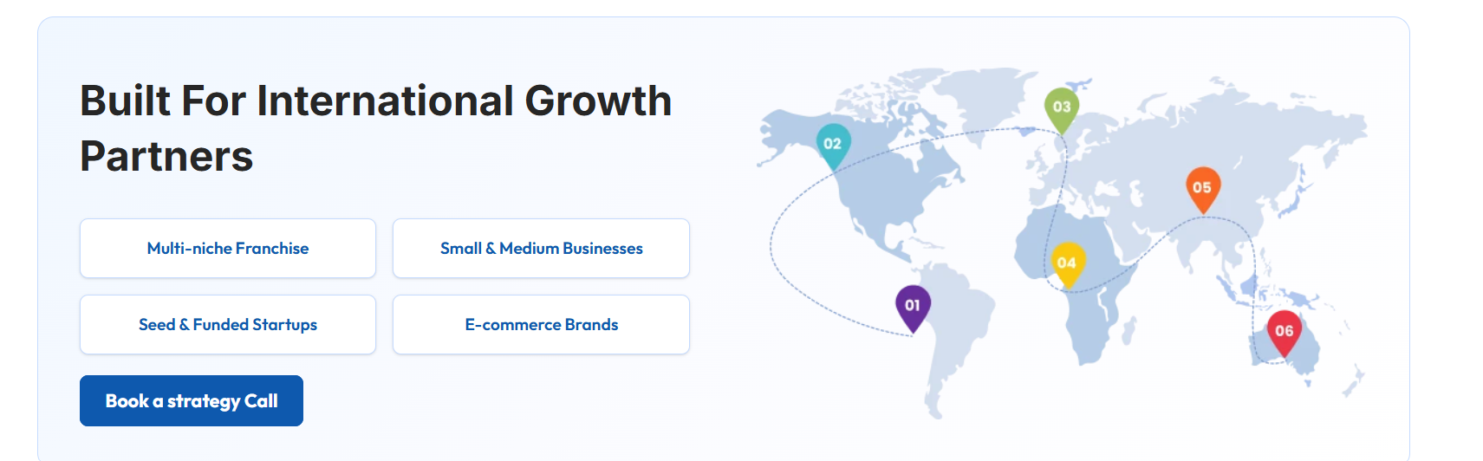

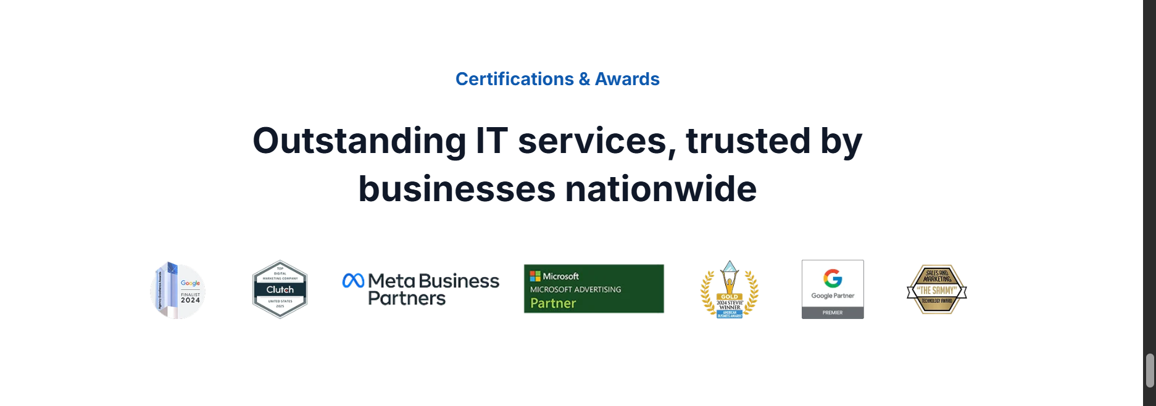
The Growth Journey
The path every brand takes with us — from first impression to compounding growth.
Stage 01 — Attention: A signal goes out. Your brand enters the digital landscape. First impressions form in milliseconds — we make sure yours lands.
Stage 02 — Discovery: Intent takes over. A signal becomes a search. We make sure you're the answer they find first.
Stage 03 — Experience They land. It has to hold. The site, the app, the page — this is where interest either converts or walks away.
Stage 04 — Identity: They start to remember you. Consistent brand and creative turn a one-time visitor into someone who knows your name.
Stage 05 — Engagement: The relationship builds. Social and content keep the conversation going long after the first click.
Stage 06 — Growth. It all compounds. Every stage feeds the next. The engine keeps running — and the numbers keep climbing.

